# Understanding Undercuts in Plastic Injection Molding

## Introduction

Plastic injection molding is one of the manufacturing processes that injects molten plastics into the mold and is used for large-volume production to produce thousands of identical items. Injection molding materials include thermoplastics, thermosetting plastics, metals, glasses, elastomers, etc. This manufacturing process is cost-effective while dealing with mass production as it is fast, accurate, and highly repeatable. It is used by countless manufacturers in the field of automotive, industries, consumer goods, packaging, and so on. It is considered to be a high-speed process as once a mold is fabricated, cycle time for each plastic ought to take as little as 30 seconds.

For a detailed understanding, watch this video: <https://youtu.be/QeaZzjf4DBM>

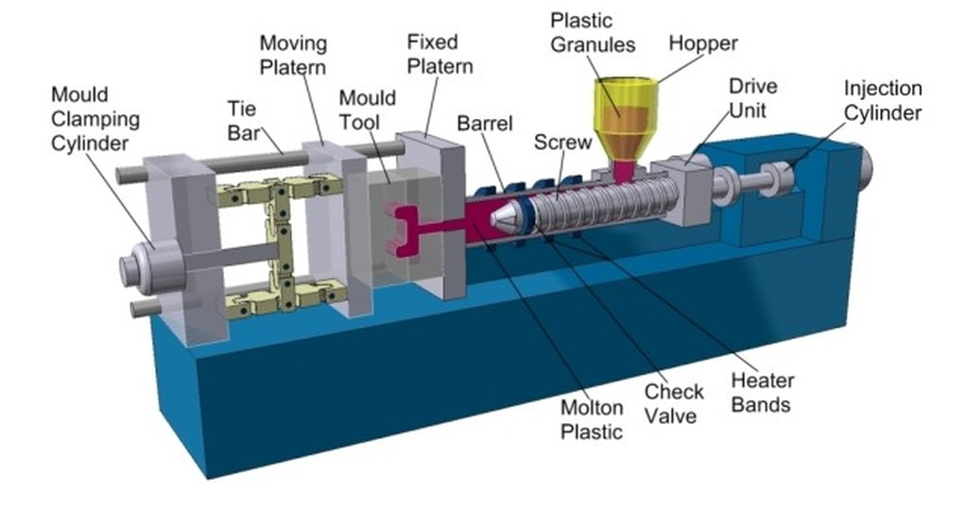

Figure Plastic injection molding

Source: <https://predictabledesigns.com/introduction-to-injection-molding/>

An **undercut** is a feature that may or may not make the ejection of a part from the mold difficult. Power switch slots, teeth of a thread, and locking tabs are prime examples of undercuts that needs to be avoided until and unless the design is indispensable. It is true that special tooling can be used to safely eject the part from the mold even when an undercut is present. But this results in an increment of cost as well as the time frame of the project.

## what are undercutsUnderstanding Undercuts

Figure Undercut in molded part

Injection molding undercuts are the features that are not orthogonal to the mold parting line, preventing them from easily or impossible to be ejected from the mold in the direction of the mold opening. However, it also offers some benefits; the presence of undercuts in injection molding lessens or replaces the requirement of secondary processes or assembly. For example, threading into an injection molded part design introduces an undercut feature, simultaneously preventing the need to machine threads in the molded part. Also, undercuts are usually used in mold designs to add assembly features to the injection molded part for better fitting, eliminating the need for other finishing operations.

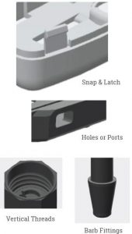

Source: <https://xcentricmold.com/undercuts-in-plastic-injection-molding/>

### The impact of undercuts on mold design and product functionality

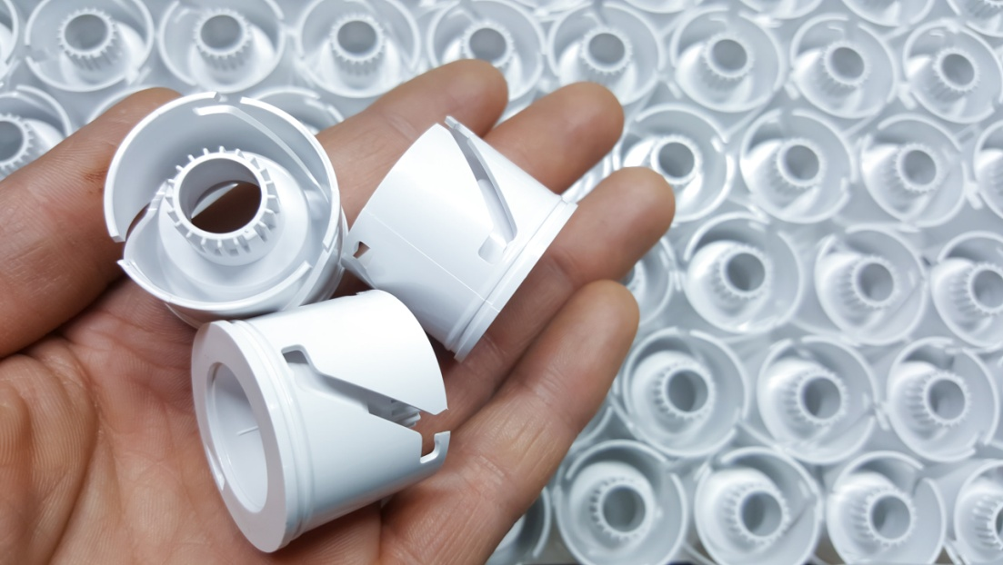

Figure Undercuts

<https://www.fictiv.com/articles/product-study-undercuts-in-injection-molding>

|  |  |  |
| --- | --- | --- |
| **S.N.** | **Impact on Mold Design** | **Impact on Product Functionality** |
|  | **Complexity**: Undercuts add complexity, cost, and manufacturing time as they need sliders, lifters, or side actions to release the part without any kind of damage. | **Part Design**: Undercuts can limit the design possibility which leads designers to make compromises in the product design to hold the molding process. |
|  | **Parting Line**: Undercuts determine the position of the parting line (boundary where mold separates in 2 halves). | **Assembly:** Products with undercuts sometimes require more assembly steps that may result in errors and inefficiency. |
|  | **Mold Material and Construction:** Due to the complexity of undercuts, higher-grade materials, and precision machining may be required. | **Quality and Tolerance:** Undercuts affect dimensional accuracy due to distortions when the part is released from the mold. |
|  | **Cycle Time:** Undercuts may result in longer cycle times, reducing the overall production output. | **Strength and Structural Integrity:** If undercuts create thin walls or intricate geometries overall strength and structural integrity of the molded part diminishes. |

## Types of Undercuts

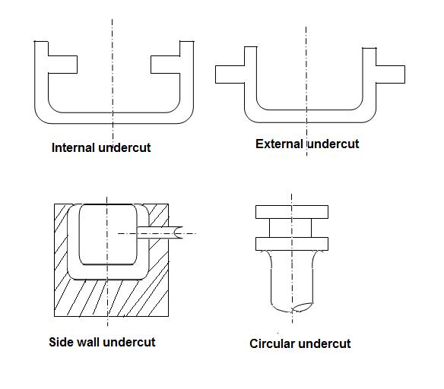

Source: <http://plasticlecturenotes.blogspot.com/2011/09/undercuts.html>

Undercuts can be of two types known as external undercuts and internal undercuts.

* **External Undercuts:** These are featured on the outer surface of the molded part identified by grooves, indentations, or protrusions on the external surface of the part. For demolding and easy removal of parts with external undercuts, lateral moving elements like sliders (for simple undercuts), splits, and core pullers (for complex undercuts).
* **Internal Undercuts:** These are located on the inside contours of the molded part and are more challenging to deal with when compared to external undercuts since they consist of intricate geometries that cannot be dealt with by lateral movement alone; they need side actions or side pulls. But, even with side actions, the part may remain attached to the core which results in the need for further manual intervention or secondary processes.

### Undercut release mechanisms

The dedicated techniques that are used in mold design to aid the smooth and efficient part removal from the mold cavity while still maintaining the integrity of the part and mold of a part with undercuts are called the undercut release mechanism. Some of the common undercut release mechanisms are side actions, lifters, core pullers, mold splits, hydraulic/mechanical actuators, and manual intervention. It is necessary to carefully analyze the geometry and requirement of material properties for that part to successfully select the most appropriate release mechanism. Proper selection as well as implementation of undercut release mechanisms is key to successful as well as cost-effective manufacturing processes that involve undercuts. The selection of the proper undercut release mechanism depends on:

* Design Complexity
* Type of undercuts
* Location of undercut
* Production volume
* Budget/cost constraints

## Designing for Undercuts

### Challenges of undercutting injection molding

1. Mold Complexity: Since, undercuts require the addition of slides, lifters, or core pullers; the design complexity is higher in mold design with undercuts.
2. Draft Requirements: [Draft angles](https://www.rapiddirect.com/blog/injection-molding-draft-angle/) should be reduced or kept zero while dealing with undercuts, which increases the challenge to obtain smooth part removal.
3. Material Selection: Certain materials can stick or deform more during ejection, resulting in part damage, rejection, or increased scrap rates. Also, more issues generate with more rigid materials.
4. Parting Line Challenges: Inappropriate placement of parting lines can lead to poor material flow that leads to molding defects like voids, incomplete filling, sink marks, flash, or difficulty in the assembly of the molded parts.
5. Increased Cycle Time: Undercuts can be ejected safely; however it requires additional steps like actuating side actions or lifters. This significantly increases the overall cycle time while also reducing production efficiency.
6. Tooling Costs: As you know, the use of additional components and mechanisms to put up with undercuts means higher costs. They are usually expensive to maintain as well.

**4.2) Strategies for incorporating undercuts in design**

Source:

**1. Position Parting Lines**

The parting line is the intersection plane between two molds which helps to solve the undercut problem if they are positioned properly. The reason behind this is: when the feature is divided into two halves by the parting line, the part can be easily ejected from the mold without having the need to include an undercut.

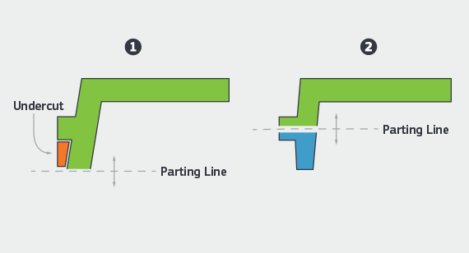

**2. Utilize Side-Actions Feature**

A side-action core is an insert that slides out of the part during the ejection of the part. This feature can be automated to slide in at the same rate as the other parts of the mold and retract when they retract. The molded part is available for extraction only once the side action has been completed which helps in proper extraction. The side action core needs to be perpendicular, and this critical requirement increases the complexity of the mold design.

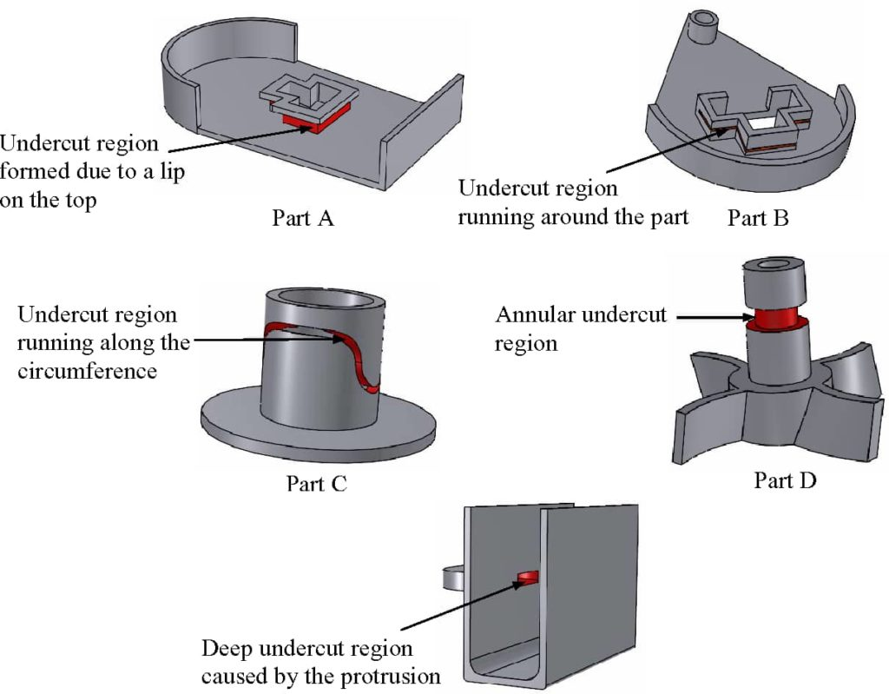

**3. Use Bump Offs**

Bump offs are the best choice when dealing with elastic materials like lens covers, phone cases, etc. After the molding process is complete, this insert is removed first and then the main part is ejected normally. However, there are some restrictions while using this mechanism:

* The part must be flexible and elastic.
* The under feature must not be stiff features like corners and ribs.
* The lead angle must be between 300 and 450.

**4. Choose Hand-Loaded Inserts**

Hand-loaded inserts are different metal pieces that the operator manually places in the mold to prevent any plastic from flowing in. This facilitates the ejection process as the operator is free to remove the piece once the cycle is over and reuse it for the next batch. This is a manual process, which means that it’d naturally take more time to complete. Furthermore, the high temperatures involved create a safety concern as well. Workers use safety gloves and goggles but there is always a chance of burning yourself.

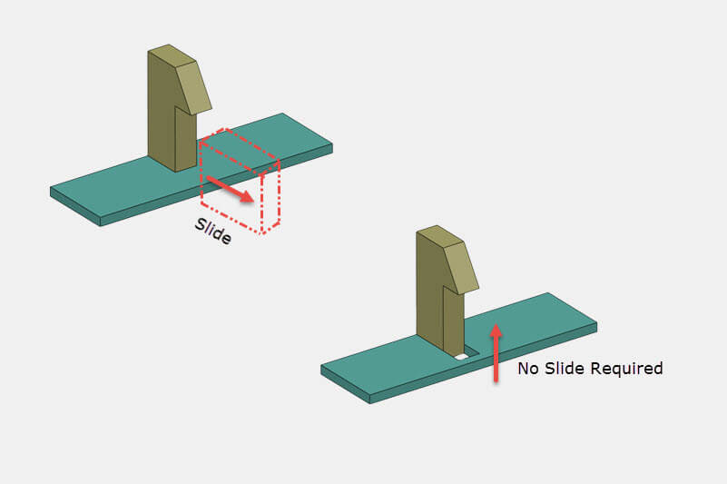

**5. Incorporate Shutoffs**

If shutoffs are used, they can eliminate the need for side action or hand inserts, reducing the cost and increasing the production rate. These are temporary obstructions that use hooks, clips, etc. in order to snap-fit and prevent the flow in particular regions of the design.

**6. Lifters**

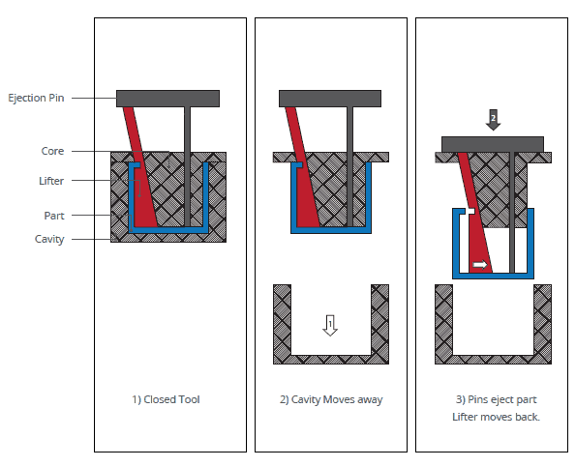

Lifters are somewhat similar to the side action mechanism, but lifters have an angled insert that moves away from the molded part at an angle in order to release itself from the undercut. This mechanism is the most cost-effective solution among other strategies for incorporating undercuts as it can be automated and also becomes a part of the standard ejection process.

**4.3) Role of software in designing for undercuts**

1. **3D Modeling and Visualization:** 3D modeling software helps in creating the CAD model that helps in the visualization of parts to properly understand the complexities and challenges that can be resulted from undercuts. Then, they can plan their design strategies according to that.
2. **Draft Analysis:** Specialized software tools helps in draft analysis to ensure enough draft angles are created to aid smooth part removal.
3. **Mold Flow Analysis:** With mold flow analysis software, you can identify the flow issues that might occur and then you can alter your design strategies accordingly.
4. **Undercut Release Mechanism Simulation:** With the help of this software, you can assessthe effectiveness of different mechanisms and then make the selection of one to ensure safe and effective part ejection.
5. **Toolpath Generation:** This software can create toolpaths for CNC machines that help to achieve precise mold geometry. These are specially used for machining complex mold features to facilitate their smooth part ejection.

## Overcoming Undercut Challenges in Injection Molding

Collapsible cores and expandable cavities are specialized features that are used in undercut injection molding to ensure the safe ejection of parts.

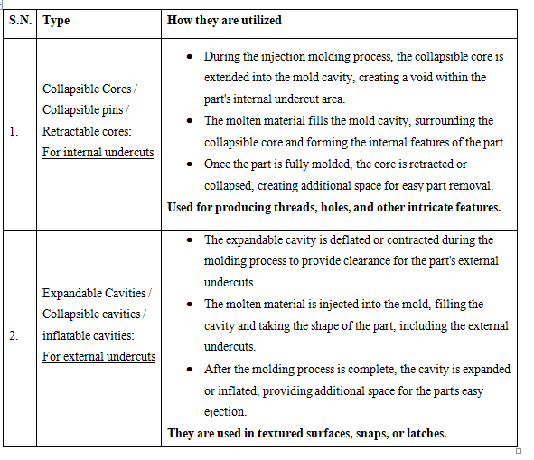

## Case Studies

Successful undercut designs are observable in various industries:

1. Automotive Industry:
   * Door handles with integrated locks
   * Dashboard components like buttons, switches, and display screens
2. Consumer Electronics:
   * Mobile phone cases requiring snap-fit features like edge latches or clips
   * Laptop hinges and closures
3. Medical Devices:
   * Inhalers and drug delivery devices
   * Prosthetics and orthotics
4. Packaging and Containers:
   * Bottle caps and closures
   * Snap-fit packaging for making products accessible while keeping them safely sealed.
5. Consumer Goods:
   * Children's toys
   * Kitchen gadgets and utensils
6. Aerospace and Defense:
   * Aircraft interior components for hidden fasteners
   * Military equipment like weapon attachments and communication devices
7. Sporting Goods:
   * Bike helmets
   * Footwear

## Innovative solutions for undercut challenges

1. Multi-Material Molding: Successful ejection of parts with undercuts can be attained with the integration of different materials having varied levels of flexibility or shrinkage.
2. Conformal Cooling: Conformal cooling channels can improve the cooling process and check the sticking of parts with undercuts.
3. Micro-Textured Surfaces: To minimize friction and adhesion, micro-textured or nano-textured surfaces can be applied to mold components. It helps to ease the release of parts with undercuts. Similarly, these textured surfaces can reduce the requirement for complex release mechanisms.
4. Magnetic Release Mechanism: Ejection of the parts with undercuts can be promoted with the application of magnetic release mechanisms into molds. Parts can be released without the need for extensive side actions or lifters, by utilizing controlled magnetic forces.
5. Smart Coatings and Lubricants: Using specialized coatings or lubricants, friction can be reduced on mold surfaces to improve the release of parts with undercuts.

## Conclusion

Summing up, despite the challenges that occur due to the presence of undercut in the mold design, proper understanding and management of undercut can lead to several benefits as well. With the proper parting line placement, the use of an appropriate release mechanism, and the use of advanced software, an undercut may prove its worth in the sense that it can be used to increase efficiency, and functionality while focusing on aesthetics. It wouldn't be wrong to say that proper play with the knowledge of undercut might even shape the future landscape of plastic injection molding.